Sens PNG Limited

Company Profile
Sens PNG Limited is a Papua New Guinea-owned wholesale distribution company established to improve access to quality products at competitive prices. The company was founded to support independent retailers and small businesses that need reliable wholesale supply without depending on large retail chains that operate in both wholesale and retail markets.
In Papua New Guinea, many major supermarkets import and distribute their own products while also operating retail outlets, making it difficult for smaller retailers to access fair pricing and consistent supply. Sens PNG Limited addresses this gap by operating as a dedicated wholesale partner for retailers, wholesalers, and businesses across the country.
Through strong international supplier relationships, Sens PNG Limited sources FMCG and automotive products that offer quality, value, and reliability. The company is focused on long-term partnerships and a professional distribution network that helps customers grow and compete effectively.
With warehouses in Lae and Port Moresby, and dedicated teams based in both locations, Sens PNG Limited is well positioned to serve customers across Papua New Guinea. This dual presence allows us to provide reliable stock availability, responsive customer support, and efficient distribution to businesses throughout the country.

Our Product Portfolio

FMCG Distribution
Sens PNG Limited distributes a growing range of trusted consumer brands, including:
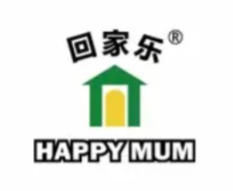
- Punjas Range of Products
- Happy Mum Range of Sauces
- Happy Mum Salt
- Nachorittos Corn Chips

These brands are valued for their quality, affordability, and strong appeal to consumers throughout Papua New Guinea.

Automotive Distribution
The company also distributes quality tyre brands, including:
- Kapsen Tyres – Quality tyres for passenger vehicles, SUVs, and light commercial vehicles.
- Long March Tyres – Durable tyre solutions for trucks, buses, heavy transport operators, and commercial fleets.

Vision
To be Papua New Guinea’s most trusted independent wholesale distributor, giving retailers fair access to quality products, competitive pricing, and reliable supply chains that support sustainable growth.

Mission
To source and distribute quality products from leading global suppliers while delivering value, affordability, and dependable service to help retailers and businesses across Papua New Guinea compete and succeed.

Why Choose Sens PNG Limited
Independent wholesale-focused business model.
- Strong international sourcing capabilities.
- Quality products at competitive prices.
- Reliable distribution and supply chain management.
- Commitment to supporting local retailers and businesses.
- Strong relationships with global manufacturers and suppliers.

Leadership

Founder & Managing Director
Navin Raju

Navin Raju is an experienced executive with more than 20 years of leadership experience across retail, logistics, supply chain, aviation, and commercial operations in Papua New Guinea, New Zealand and Australia
Before establishing Sens PNG Limited, Navin held senior leadership roles with leading organisations in Papua New Guinea, including an CEO role with CPL Group, one of the country’s largest retail businesses. His work included operational improvement, business transformation, and strategic growth initiatives across the retail and FMCG sectors.
His retail experience highlighted a key challenge for independent retailers: limited access to competitively priced, quality products due to the dominance of vertically integrated retail chains. This insight led Navin to establish Sens PNG Limited as a genuine wholesale distribution business focused on supporting independent retailers, wholesalers, and commercial customers.
With strong sourcing expertise and international supplier networks, Navin has positioned Sens PNG Limited as a trusted distribution partner committed to value, reliability, and fair access to quality products throughout Papua New Guinea.
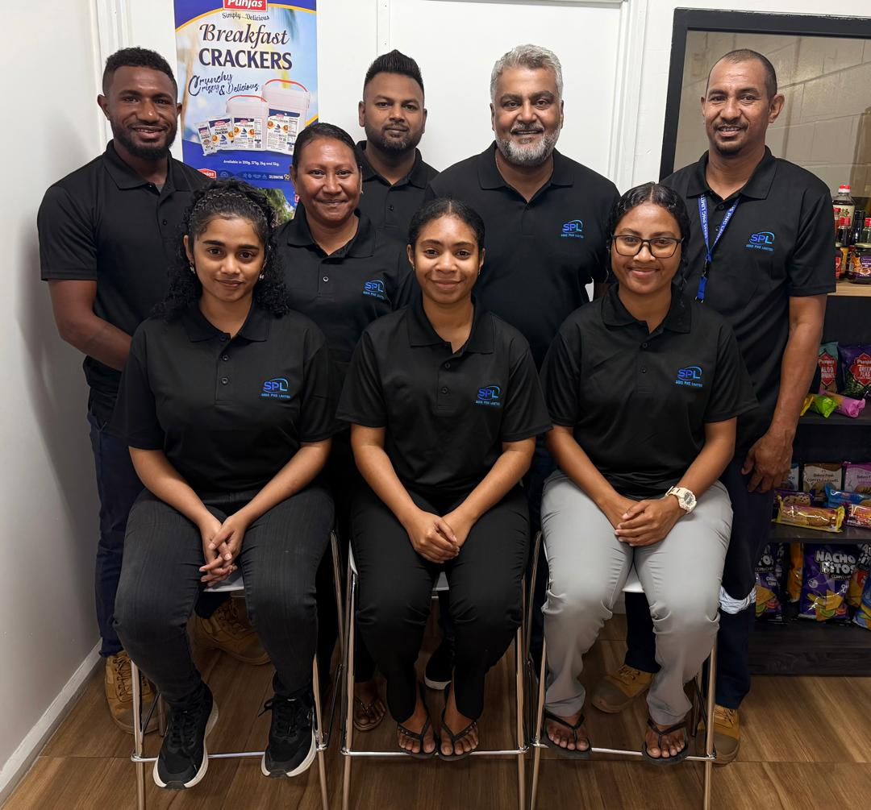

Our Commitment
At Sens PNG Limited, we believe successful retailers are essential to a strong economy. Through strategic sourcing, trusted brand partnerships, and dependable distribution, we help businesses across Papua New Guinea access the products they need to grow and succeed.
“Connecting global brands with local businesses through quality products, competitive pricing, and trusted partnerships.”

